**Lab Assignment 1**

**Dataset Given**

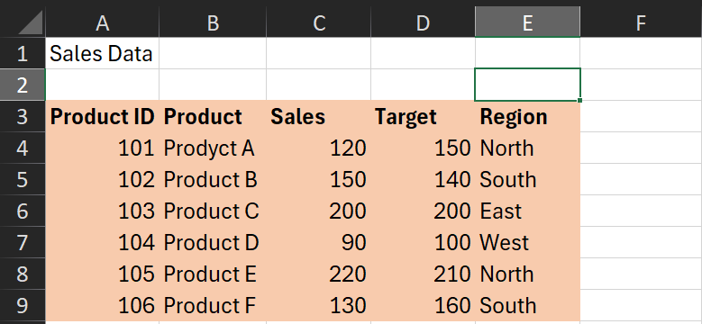

**Q1. Use the IF function to evaluate whether each product met its sales target.**

**Ans.** Formula Used:

=IF(C4>=D4, "Yes","No")

Output obtained: Met Target?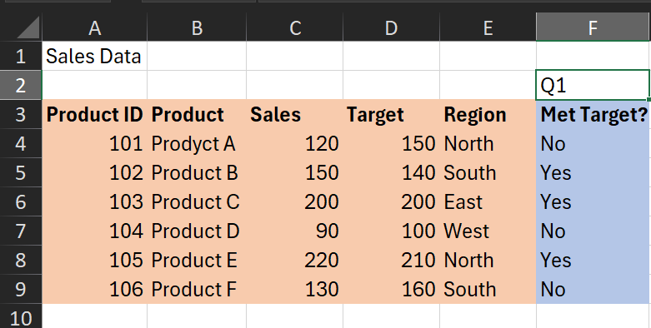

**Q2.  Use the IF function to determine if a product is eligible for a regional bonus. Products in the "North" region with sales over 200 are eligible.**

**Ans.** First we check for region if it’s North or not, afterwards we check for sales over 200. Therefore, nested IF is required here.

Formula Used:

=IF(E4="North",IF(C4>200,"Eligible","Not Eligible"),"Not Eligible"**)**

Output Obtained: Regional Eligibility

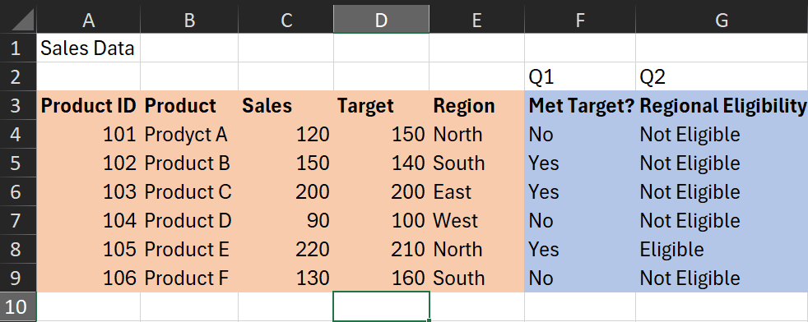

**Q3. Use nested IF functions to assign a commission rate based on sales. Sales >= 200 get a 10% commission, sales >= 150 get a 7% commission, and others get a 5% commission.**

**Ans.** Clearly, this question required the implementation of nested Ifs as there are multiple conditional checks.

Formula Used: =IF(C4>=200,0.1,IF(C4>=150,0.07,0.05))

Output Obtained: Commission

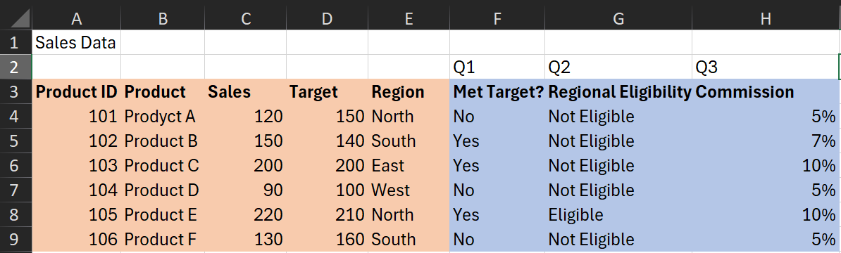

**Q4. Use the IF function to calculate a bonus amount. If sales met or exceeded the target, the bonus is 10% of the sales; otherwise, it is 5%.**

**Ans.** Bonus amount needs to be calculated, meaning the actual bonus quantity and not just the bonus percentage. Here, we can use the previously created Met Target Column since it already checks if a product has met its sales target or not.

Formula Used: =IF(F4="Yes",0.1*C4,0.05*C4)

Output Obtained: Bonus

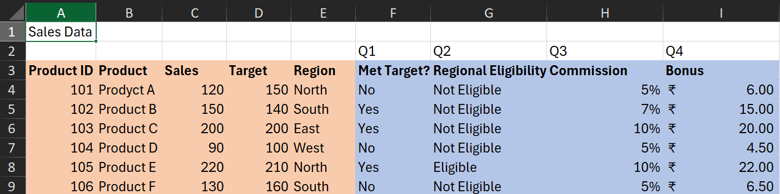

**Q5. Use the IF function to categorize sales performance as "Excellent" (>=200), "Good" (>=150), or "Needs Improvement" (<150).**

**Ans.** Again, multiple conditional statements meaning nested Ifs required.

Formula Used: =IF(C4>=200,"Excellent",IF(C4>=150,"Good",IF(C4<150,"Needs Improvement")))

Output Obtained: Performance

